QuickStep Motors
Now available: integrated stepper motors from JVL

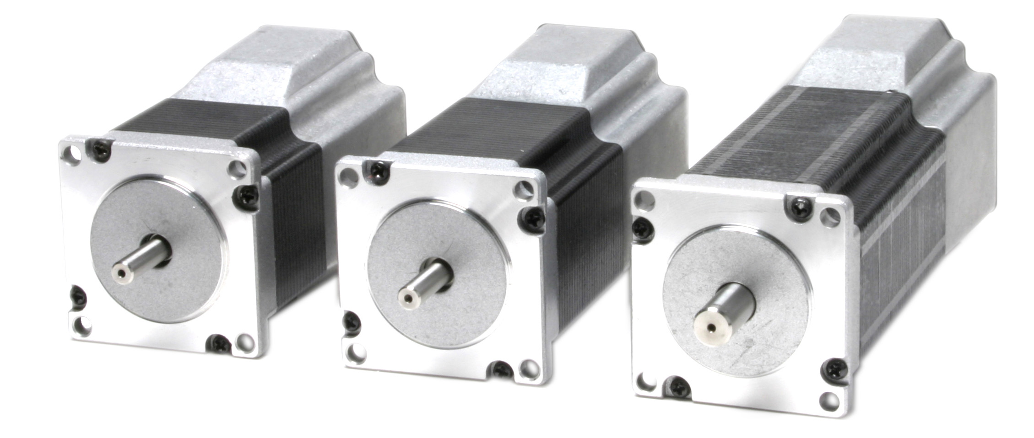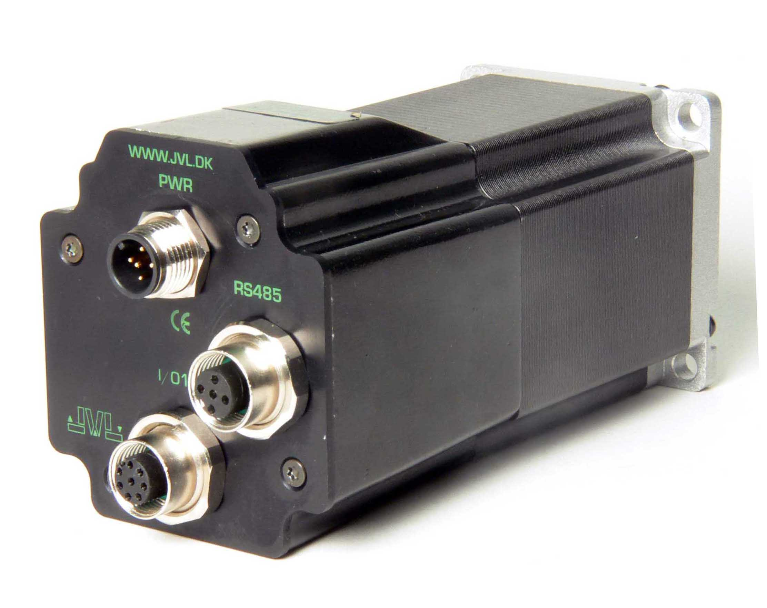

Since the introduction of the integrated AC servo motor — the MAC motor — several years ago, there has been a great deal of interest in these motors. This is because the benefits of integrating the driver and controller in the motor unit are so numerous.

QuickStep is a new series of integrated stepper motors from JVL. They are available in a wide range, offering various functionality and combinations. The basic unit is a high-torque step motor with flange dimensions of 57x57 mm (NEMA23). The housing is constructed to provide IP55 or better protection. One or more PCBs and various connectors can be mounted in the housing to provide the various models. Among the many features can be mentioned:

- Pulse/direction driver.
- Serial RS485 position controller with graphical programming.
- Point-to-point or multiaxis operation up to 255 axes on the same RS485 bus.
- Canbus, CANopen 402 or Devicenet optional.
- Optional magnetic encoder with resolution of up to 1024 pulses/revolution for stall detection.
- 8 IO that can be configured as input, output or 10bit analog input
- Electronic gearing for following an encoder or pulse train in a arbitrarily selectable controlled ratio.
- All modules are supplied with M12 connectors. Customer-specified connectors or cables for OEM orders.
- High speed position capture.
- Double voltage-supply available so that position and parameters are maintained during emergency stop.
- MAC motor protocol so that MAC motors and QuickStep motors can be connected to the same RS485 bus.
- Commands for simple PLC/PC set-up and communication.
- Power supply 12-48V DC delivering high torque at high speed.
- 1.1Nm, 1.6 Nm, and 2.5 Nm versions.
- Fixed 1600 pulses/revolution for version with built-in position controller.
- 200, 400, 800, 1000, or 1600 pulses/revolution for versions with pulse/direction inputs.

Backlash-free and planetary gears with ratios of 3, 5, 10, 20, and 100 can be supplied as standard.

Further information can be obtained from JVL Industri Elektronik A/S, Blokken 42, 3460 Birkerød, Denmark,
tel.: +45 45 82 44 40. E-mail: jvl@jvl.dk

Download text and photos directly from:
http://www.jvl.dk/default.asp?Action=Details&Item=594

